Chile and other countries with no drop off site for samples
Procedure for Sample Dispatch

Copa Cervezas de América 2019
IMPORTANT: This document aims to clearly indicate how beer samples registered on the Copa Cervezas de America contest must be sent. It serves as a complement to the contest’s Terms and Conditions, published on the website.

Responsibility and Scope
It is the person in charge of the entry’s responsibility to correctly identify, package and dispatch samples to the address pointed out by the organization.
Once samples are properly received, the organization will be responsible for their appropriate storage and transportation.
Together with our sample reception centers, we commit ourselves to:
- Store beers in a cold chamber with temperatures no higher than 4°C (*)
- Internationally ship by air to Chile.
- Move beers as little as possible.
- Not expose beers to sunlight.
- Avoid abrupt temperature changes.
(*) Beer deliver to our office address may stay up to 48 hrs. out of a cold chamber

Packaging Responsibility
The brewer must be particularly careful packaging beers appropriately inside the box. Glass to glass contact among bottles must be avoided and there must always be some kind of material in between to prevent contact, such as cardboard or packaging plastic.
It is the brewer’s exclusive responsibility to adequately and reliably package beer samples.
Poor and unsatisfactory packaging will not be the organization’s or the sample reception center’s responsibility.

Bottle labelling
It is compulsory that samples are identified with their commercial label/tag. Bottles MUST NOT have collars or any kind of identification on the bottle neck. It is the brewery’s responsibility to remove collars before samples are sent.

Shipment Costs
Sample shipment costs to Copa Cervezas de América are each participant’s responsibility.

Courrier
We recommend using a traditional well-known couriers to dispatch all samples.

Sample Identification
Each bottle must clearly point out the Entry Number. The Entry Number, which corresponds to the single identification given for the registered beer, has 3 digits and will be informed by the organization once the entry is done.
The package or box must be identified on the outside with information regarding the amount of bottles and entry number for all registered beers included in the box or package.
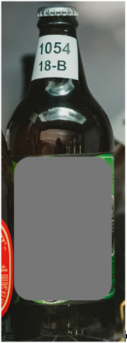
18-B
1054

Competition Entry Number
Category in which it participates
(According to the 2015 BJCP)

Sample Amount
Participants must send the following amount of samples according to each bottle size.

Bottle/Can Size | Sample Amount
Containers of 300 ml (10,1 oz) or less | 8 units
Containers from 301 ml (10,2 oz) to 499 ml (16,8 oz) | 6 units
Containers from 500 ml (16,9 oz) to 700 ml (23,7 oz) | 4 units
Containers over 701 ml (23,8 oz) | 3 units

Deadlines
Samples will be accepted during an established time window.
Samples that fail to meet the established deadlines (either before or after defined dates) will be excluded from the contest.
There will be no refund for those entries whose samples do not reach the competition.

Country | Sample Reception Opening Date | Sample Reception  Closing Date.
Beers from | June, Monday 24th, 2019 | July, Friday 12th, 2019
Chile (Santiago) | June, Monday 24th, 2019 | July, Friday 12th, 2019
Chile (Temuco) | June, Monday 24th, 2019 | July, Friday 12th, 2019

Export Documentation

Commercial Invoice or Pro-forma Invoice
Total value of the exportation invoice must not exceed US$ 30,00 (thirty US dollars). If the value of the export invoice exceed this amount, the participant will be responsible of paying the importation costs and duties.
Under no circumstance, the value of the bottle or can of beer can exceed US$0.80 per unit (80 cent of US Dollars per unit)

Air Way Bill or AWB:
The Air Way Bill must mention “simple with NO commercial value”, mention a total value of US$ 1,00 (one US dollar).

Chilean Breweries: Central and North

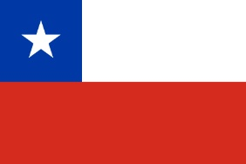
Dispatch Address
Attention: Grupo Cervezas de América SPA
Address: Don Carlos 2986, of 8,
Las Condes, Santiago, 7550173.

Phone: +562 26046578 / +562 26046579

Opening hours: Monday to Thursday: from 9:30 to 18:00
Friday: from 9:30 to 14:30
Saturday and Sunday closed.

Contact Information  Daniel Trivelli  Email: dtrivelli@gca.beer  Cel: +569 9745 283 | Camila Espinoza  Email: cespinoza@gca.beer  Cel: 569 7575 6464

Chilean Breweries: South

Dispatcht Address
Attention: Soluciones Cerveceras EIRL
Address: Los Renos 01990
Temuco, Región de la Araucanía
Chile

Opening hours:
Monday to Friday: 09:30 to 13:30 and 15:00 to 19:30 hrs

Contact Information
Karin Maturana,
Asistente Administrativa
- mail: info@solucionescerveceras.cl
- +56 45 2405849

Breweries from the world:
Only breweries that do not belong to the following countries:

Argentina | Costa Rica | Peru
Brazil | Ecuador | Uruguay
Canada | México | USA
Chile | Panamá
Colombia | Paraguay

INCOTER
Deliver condition: DDP (Delivery Duty Paid)

Dispatcht Address
Attention: Grupo Cervezas de América SPA
Address: Don Carlos 2986, of 8,
Las Condes, Santiago, 7550173
Chile

Phone: +562 2604 6579 / +562 2604 6578

Opening hours: Monday to Thursday: from 9:30 to 18:00
Friday: from 9:30 to 14:30
Saturday and Sunday closed.

Contact Information
Daniel Trivelli
Email: dtrivelli@gca.beer
Cel: +569 9745 2837

Contact Information forwarder (Notify)

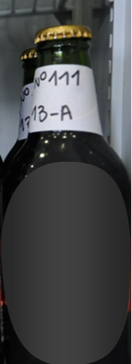
1111
Número de inscripción a la competencia
Categoría en que participa
(Según clasificación BJCP 2015)

13-A

